ASSIGNMENT[28-01-22]:

# QUESTION 1: Registration Form with validations:

## CODE:

**STYLE:**

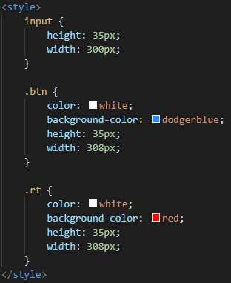

INPUT:

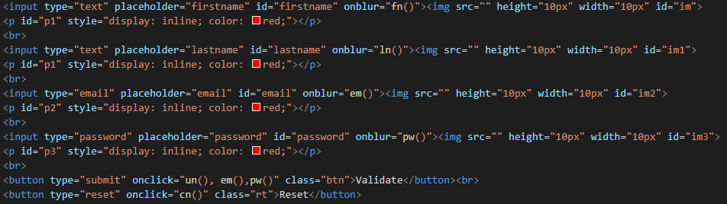

SCRIPT:

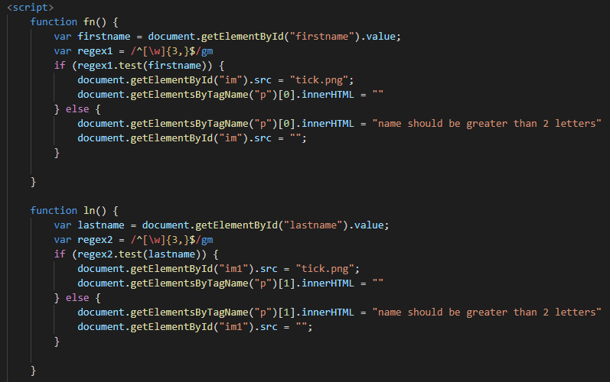

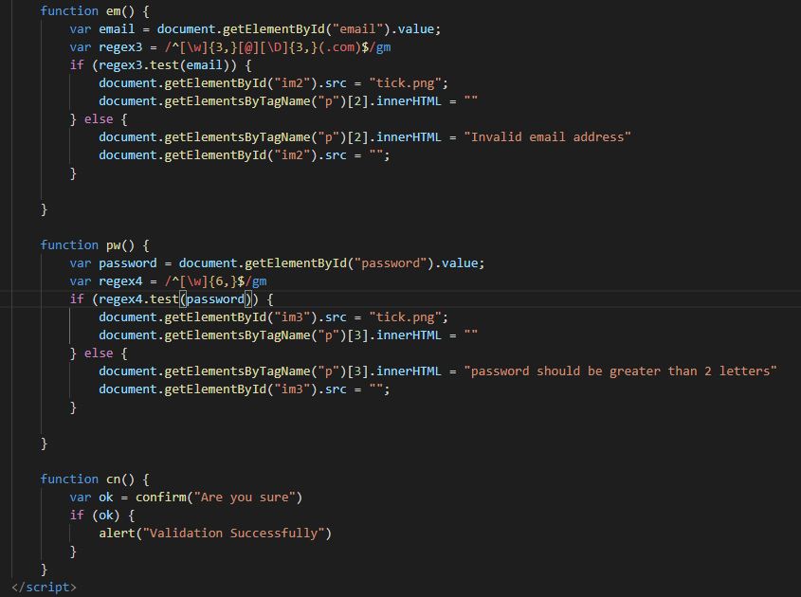

OUTPUT:

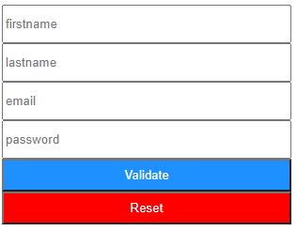

## QUESTION 2: Login Form with proper styling & use of J-query

## CODE:

**STYLE:**

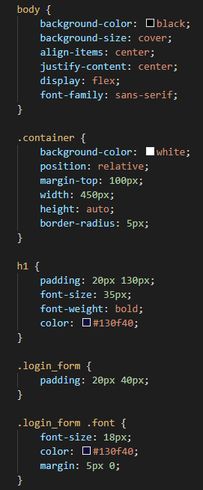 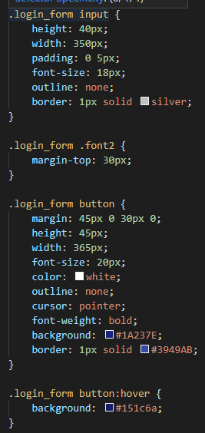

**SCRIPT:**

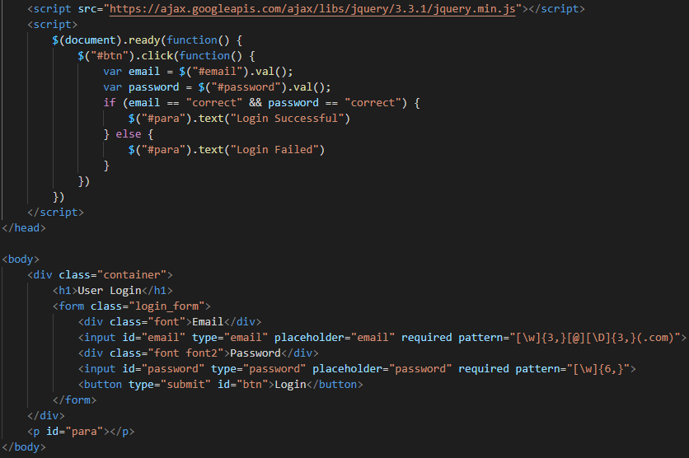

## OUTPUT:

### 